1# 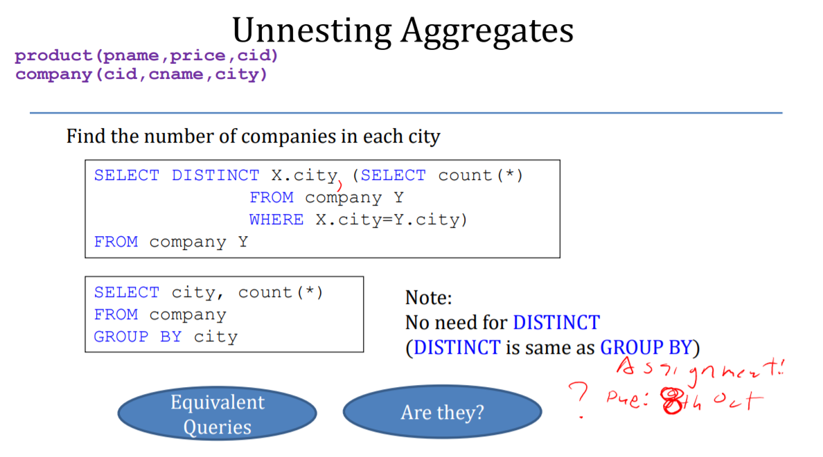

I personally think that these two queries are equivalent. Because since DISTINCT X.city is used instead of GROUP BY city in the first query, we can see that X.city = Y.city and it does make sense while looking at the name of the table which is company. The only thing that is making the query confusing is the use of X and Y in the first query.

2#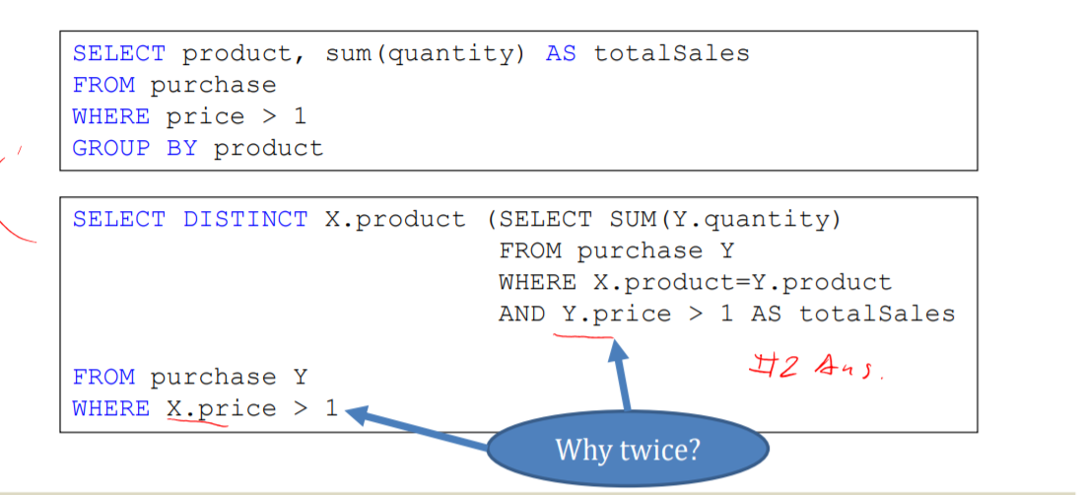

On the second problem, it’s clear that these two are nested queries but still, they are two different queries. So, since they are two completely different, we have to include that Y.price > 1 query in order to get the expected results unless we want to skip that selection from the SUM(Y.quantity). If we do that, what will happen? After the nested query execution, we will not be able to change the selected value from the nested query, so we already missed that Y.price selection phase for the second variable in the query. If we aren’t using that Y.price > 1 in the nested query there will be a shortage in the second variable.

Thank you

Student ID : 201923250

Name : Kobilov Ilkhomjon